**Task 2 - Alteryx Workflows**

**Part 1:**

Task_2_Preparing_the_data.yxmd

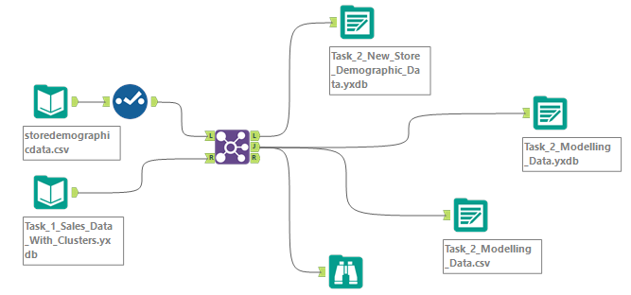

**Part 2:**

Task_2_Classification_Model.yxmd

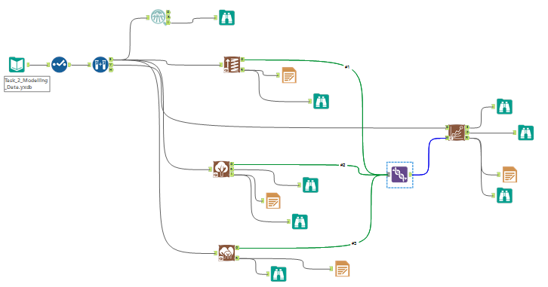

**Part 3:**

Task_2_Final_Model_Output.yxmd

